PREDICTIVE LINEAR REGRESSION MODEL PIPELINE
Name: Nazish Aziz
Internship: Progree
Task: 2

Predictive Linear Regression Model Pipeline
1. Introduction
The objective of this task was to develop a supervised machine learning regression model capable of predicting a continuous numerical value.
For this project, the House Prices dataset was used and the target variable was SalePrice. The project demonstrates a complete machine learning workflow, beginning with data loading and preprocessing and ending with model evaluation.

2. Objective
The main objectives of this task were:
- To load a standard dataset using Python and Scikit-Learn.
- To understand the structure of the dataset.
- To handle missing values.
- To apply mean imputation to numerical features.
- To encode categorical features.
- To scale numerical features.
- To train a regularized Ridge Regression model.
- To evaluate the model using R² and RMSE.
- To visualize actual and predicted values.

3. Dataset
The House Prices dataset was used for this project. It contains information about residential properties and their sale prices.
The target variable is:
SalePrice
The remaining columns were used as input features for predicting the house sale price.
The dataset contains both numerical and categorical features, making it suitable for demonstrating different preprocessing techniques.

4. Data Preprocessing
Before training the model, the data was divided into training and testing sets using an 80:20 split.
Numerical and categorical features were processed separately.
Numerical Features
Numerical features were processed using:
- Mean imputation for missing values.
- StandardScaler for feature scaling.
Categorical Features
Categorical features were processed using:
- Most-frequent value imputation.
- One-hot encoding.
The preprocessing steps were combined using a Scikit-Learn ColumnTransformer.

5. Model
Ridge Regression was selected as the regression algorithm.
Ridge Regression is a regularized form of Linear Regression. Regularization helps reduce the effect of overly large model coefficients and can improve model stability.
The Ridge model was combined with the preprocessing steps into a complete Scikit-Learn pipeline.

6. Model Training
The model was trained using the training dataset.
After training, predictions were generated using the unseen testing dataset.
This allowed the model to be evaluated on data that was not used during training.

7. Evaluation
Two evaluation metrics were used:
R² Score
- R² measures how well the model explains the variation in the target variable.
- R² Score: 0.8843
Root Mean Squared Error
- RMSE measures the magnitude of prediction errors. Lower RMSE generally indicates smaller prediction errors.
- RMSE: 29791.98

8. Results
The actual and predicted house prices were compared using a scatter plot.
The Actual vs Predicted graph helps visualize how close the model predictions are to the actual house prices.
The prediction error plot was also generated to examine the distribution of prediction errors.
Actual vs Predicted House Prices

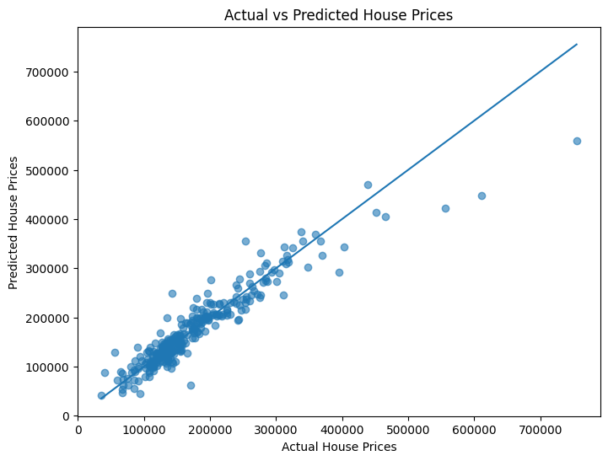

Prediction Error Plot
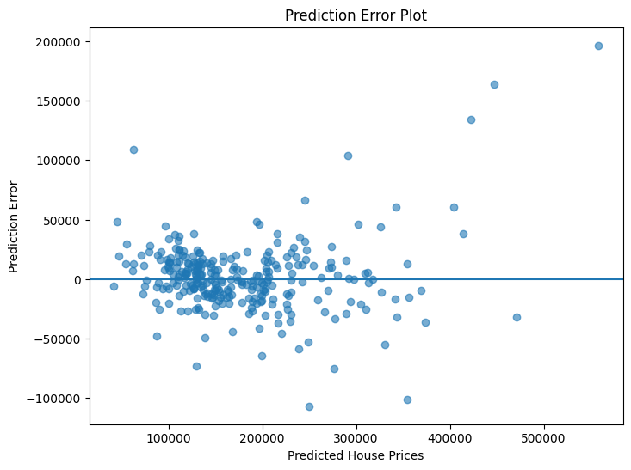
9. Conclusion
A complete supervised machine learning regression pipeline was successfully developed.
The project included data exploration, missing value handling, categorical encoding, feature scaling, Ridge Regression, prediction, and evaluation.
The model was evaluated using R² and RMSE, while visualizations were used to compare actual and predicted house prices.
This task provided practical experience with building a complete regression workflow using Python and Scikit-Learn.

10. Learning Outcomes
- Through this task, I learned how to:
- Work with a real-world regression dataset.
- Identify numerical and categorical features.
- Handle missing values.
- Apply mean imputation.
- Encode categorical variables.
- Scale numerical features.
- Build a Ridge Regression model.
- Create a machine learning preprocessing pipeline.
- Evaluate regression models using R² and RMSE.
- Visualize model predictions and errors.

